|  |
| --- |
|  |
| DBMS Lab Assignment-IV |
|  |
|  |
| **B.Tech (Computer Engg) V Semester** |
| **SAURABH MEHTA**  **11CSS54** |

|  |
| --- |
|  |

***CURSORS***

**Skill Table**

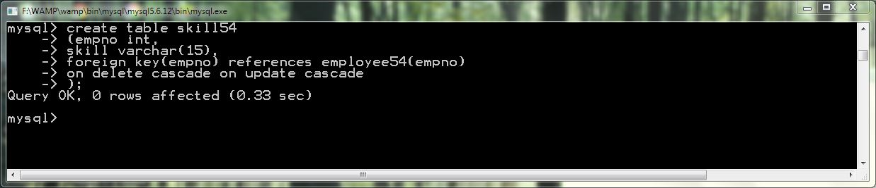

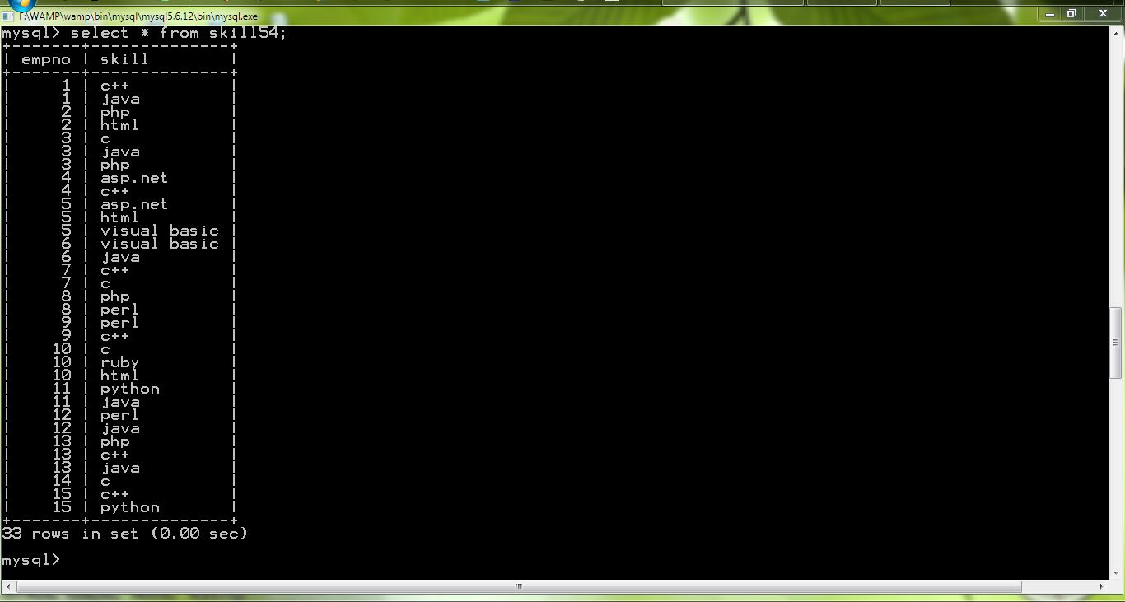

**Employee Table**

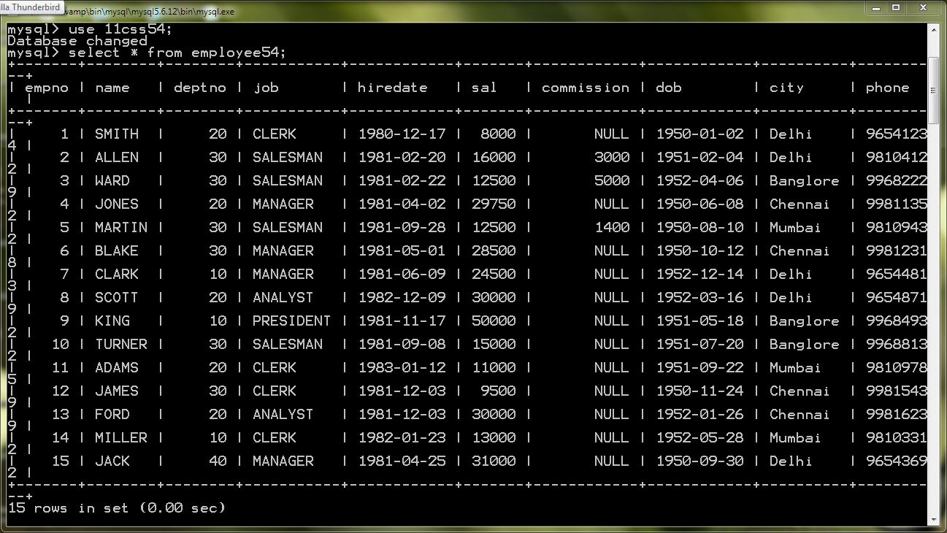

**Procedure eksill**

create procedure eskill()

begin

declare f int default 1;

declare skill varchar(15);

declare name varchar(10);

declare str varchar(500) default "";

declare str1 varchar(500) default "";

declare str2 varchar(500) default "";

declare name1 varchar(20) default "";

declare cur cursor for select e.name,s.skill from employee54 as e,skill54 as s where e.empno=s.empno order by e.name;

declare continue handler for not found set f=0;

open cur;

myloop:loop

if f=0 then

leave myloop;

end if;

fetch cur into name,skill;

if name=name1 then

set str="";

else

set str2=concat(str2,"\n",str1);

set str1="";

set str1=concat(str1,"\n",name," ");

end if;

set name1=name;

set str1=concat(str1,"",skill,",");

end loop;

set str2=concat(str2,"\n",str1);

select str2;

close cur;

end;;

